First Knowledge of Animals
(aka, Who Am I? cards)

MATERIALS:
- Picture cards of 46 of animals (30 vertebrates and 16 invertebrates)
- Name slips (word reading)
- Story cards – aka, Who am I? stories
  - Complete AMI-aligned set with 46 animals: purchase here
  - Sets by class of animals: purchase here (note: You’ll need to purchase around 5 sets of cards to make the complete collection)

DIY note: I have included the names of 30 common vertebrates and 16 common invertebrates at the end of this document, in case you want to create your own cards. You don’t have to use these animals; the goal is to offer a mix of animals the child is somewhat familiar with. You can include animals local to your region, provided your child knows a thing or two about them.

The picture cards, name slips and story cards should have numbers on the back, which serve as the ONLY control of error. The children should rely mostly on their knowledge and the support of their older siblings (when available).

Purpose:
- Encourages the children to explore the way of life of these animals: where they live, what they eat, how they reproduce, whether/how they look after their young, etc.

- We want to give the children an initial idea of diversity and classification, because classification provides order. We want to offer classification in a way that children can use their power of observation, even if that means that we’ll have to use more old-fashioned methods of classification. The children have many years ahead of them in which to refine, revise, and update their methods and choices of classification.

PRESENTATION:
- Choose from 8 to 12 assorted animal cards, both vertebrates and invertebrates.
- Have a conversation with the children regarding each animal to find out what they do and don’t know. If they don’t know what an animal is, give some general information. For the ones they do know, ask questions like:
  - What is it called?
  - Where does it live?
  - How does it behave?
  - Does it live alone or in groups?
  - What can you tell about it from looking at its body?
  - What does it eat?
- Tell the children that if they want to, they can find out more about any of the animals that interest them.

First Stage: Word reading
Give the children the labels with the names of the animals and invite them to match the label to the animal card.

Second Stage: Who Am I? (Story cards)
If the children can tackle the story cards, hand out these cards to the children. They can read them and match them.
Note: The cards should be written in the first person.
Example: I look like a star, but I’m not. I even have a mouth and with my strong arms I can open a clam underwater and eat it. If I lose an arm, I can even re-grow it. When I die and dry out you can find and collect me along the beach. Do you know what I’m called?

The answer would be a sea star.

The children can then proceed on their own with the rest of the cards, like the woodpecker example below.
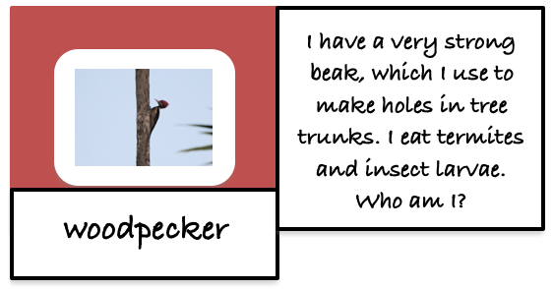

You can extend the engagement with these cards by doing the following:

Separate them into vertebrates and invertebrates - play the game with the vertebrate cards one day, and the same game with the invertebrate cards another day.

Play a matching game with a subset of the cards (about 6-8 cards at a time, depending on your child’s ability and stamina). The picture cards and the text cards are upside-down on two rugs next to each other. The child has to flip a text card, read it, and find the matching animal card to make the pair. Take turns so that the child isn’t doing all the reading!

Once the child is familiar with the material, introduce the concept of vertebrates and invertebrates and then do a card sort using the picture cards from this set.

Using the cards as inspiration, invite the child to make their own set of 3-5+ cards, which they can “present” to a sibling or relative.

Use one animal card at a time and use the Q&A research cards (see Timeline lesson) to learn more about the animal and start encouraging research.

30 Common Vertebrates

Mammals:
- Dogs
- Cats
- Cows
- Horses
- Elephants
- Mice
- Rats
- Rabbits
- Squirrels
- Deer

Birds:
- Pigeons
- Sparrows
- Crows
- Chickens
- Ducks
- Eagles

Reptiles:
- Lizards
- Snakes
- Turtles
- Crocodiles

Amphibians:
- Frogs
- Toads
- Salamanders
- Newts

Fish:
- Goldfish
- Tuna
- Salmon
- Sharks
- Clownfish
- Eels

16 Common Invertebrates

Insects:
- Ants
- Bees
- Butterflies
- Beetles
- Flies
- Mosquitoes

Arachnids:
- Spiders
- Scorpions

Crustaceans:
- Crabs
- Lobsters
- Shrimp

Mollusks:
- Snails
- Octopuses
- Squids

Echinoderms:
- Sea stars
- Sea urchins

